

Mocktime

Designing a reliable mock examination system to enhance student learning experience and tutor interaction



Jomin Kaitholil George

Student ID: 130303750

G400 BSc Computer Science

Supervisor: Dr. Ellis Solaiman

Date: Monday, 02 May 2016

Total Pages:

Word Count:

# **Abstract**

Web-based mock examination will be used towards to educational institution, to help students prepare towards to their end of year/term exams. In addition, it is a way for the examiner to analyse and gather statistics on student’s knowledge. This could be seen as a way for lectures and students to interact with each other and to be able to build a stronger understand in the contents that has been delivered at the lecture. With the use of an online mock examination system it will be easier for the lecturer/teacher to add or modify any questions that they believe is related to the content which was taught at the lecture. This way, students will have the ability to log into the online mock examination with their login credential and access it from anywhere at any time to analyse their learning progress.

# **Declaration**

“I declare that this dissertation represents my own work except where otherwise stated.”

Jomin Kaitholil George

# **Acknowledgements**

I would first of all like to thank my project supervisor, Dr. Ellis Solaiman, for introducing this field to me and also for all the valuable support that he has provided throughout the process.

Last but not least, I would like to thank my parents for all the support they have given to me throughout my entire university life.

**Contents**

**Abstract** 1

**Declaration** 2

**Acknowledgements** 3

**Chapter 1: Introduction** 7

**1.1.** **Introduction** 7

**1.2.** **Motivation** 7

**1.3.** **Project Aim and Objectives** 8

**1.3.1** **Aims** 8

**1.3.2** **Objectives** 8

**1.4.** **Deliverables** 9

**1.5.** **Relevance to Degree** 9

**1.6.** **Project Plan** 9

**1.7.** **Project Structure** 10

**Chapter 2: Background Research** 11

**2.1** **Existing Examination Tools or Products** 11

**2.1.1** **Respondus** 11

**2.1.2** **Moodle Quiz** 12

**2.1.3** **Conduct Exam** 13

**2.1.4** **Speed Exam** 13

**2.1.5** **Pro Profs Quiz Maker** 14

**2.1.6** **Existing Products Summary** 15

**2.2** **Graphical Visualisation** 16

**2.2.1** **Bar Diagrams** 16

**2.2.2** **Pie Diagrams** 16

**2.2.3** **Line Diagram** 16

**2.3** **Web Frameworks** 17

**2.3.1** **PHP Frameworks** 17

**2.3.1.1** **Codeigniter** 17

**2.3.1.2** **Zend** 17

**2.3.1.3** **Summary of PHP Framework** 18

**2.3.2** **Bootstrap** 18

**2.4** **Possible Technologies** 19

**2.4.1** **Client Side Scripting** 19

**2.4.1.1** **HTML 5** 19

**2.4.1.2** **CSS3** 19

**2.4.1.3** **JavaScript** 19

**2.4.1.4** **JQuery** 19

**2.4.2** **Server Side Scripting** 20

**2.4.2.1** **PHP** 20

**2.4.2.2** **ASP.Net** 20

**2.4.2.3** **Summary of Server side Scripting** 20

**2.5** **Version Control** 21

**2.6** **Database** 21

**2.6.1** **MySQL** 21

**2.6.2** **PostgreSQL** 21

**2.6.3** **Summary of Database** 21

**2.7** **Methodology** 22

**2.7.1** **Agile Methodology** 22

**2.7.2** **Waterfall Model** 22

**2.7.3** **Summary of Methodology** 22

**Chapter 3: Requirement Gathering and Analysis** 24

**3.1** **Introduction** 24

**3.2** **Preliminary Research** 24

**3.2.1** **Interviews** 24

**3.2.2** **Questionnaires** 24

**3.3** **Client Requirements** 26

**3.3.1** **Functional Requirements** 26

**3.3.2** **Non-Functional Requirements** 28

**3.4** **Use Case** 29

**Chapter 4: Design** 34

**4.1** **Introduction** 34

**4.2** **Database** 34

**4.2.1** **Database Schema** 34

**4.2.2** **Normalization** 35

**4.2.3** **Entity Relationship Diagram** 0

**4.2.4** **Integrity Constraints** 0

**4.3** **Web Interface** 0

**4.3.1** **Navigation** 0

**4.3.2** **CSS** 1

**4.4** **System Overview** 1

**4.4.1** **User Registration** 1

**4.4.2** **User Login** 1

**4.4.3** **User Entering an Exam** 2

**Chapter 5: Implementation and Testing** 3

**Chapter 6: Evaluation** 4

**Bibliography** 5

**Websites** 5

**Books** 9

**Appendix A – Existing Products Features** 10

**Respondus** 10

**Appendix B – Preliminary Research** 12

**Candidate 1 – Transcript** 12

**Candidate 2 – Transcript** 13

**Candidate 3 – Transcript** 14

**Candidate 4 – Transcript** 15

**Candidate 5 – Transcript** 16

**Questionnaire Results** 17

# **Chapter 1: Introduction**

## **Introduction**

Examinations are used as a technique to judge someone else’s personality and knowledge in a particular area or field. Most of the examination systems provide the end user with their results as soon as the candidate finish the exam. Candidate is given a limited time to answer all the question in an exam which will be set by the examiner and after the time expires, candidate won’t be able to modify or answer any other questions. Examiner then will evaluate each candidate’s answers either by using automated or manual marking process and then the results will be published or sent to the candidate through the website. (Tests, 2012)

Web-based mock examination is aimed for Educational Institute to prepare an exam and to enhance student learning by helping them prepare towards to their end of year/term exams. Most of the examination system which are available requires the examiner to manually mark or go through each question in order to ensure that the system has marked each question for the student accurately. In most of the online examination system there would be an additional check in place for question types which are hard to mark (such as fill-in-blank, essay based questions) by the system. For example, a question like “what is a router?” can have many answer and the examiner wouldn’t be able to place a mark scheme for the online examination software to check since it is impossible (students can answer in many ways). Also it would take up more time if the examiner has to mark it manually (roughly 200 students).

Solution to this would be, not requiring examiner to manually mark the mock examination questions instead the student mark their self-based on a mark scheme that will be given at the end of the mock exam. Each student will be asked to mark their answer based on a set of marking scheme which will be provided by the examiner. This way the examiner can see how well the students understood the material which was taught at the lecture. The key point here is that it’s a mock exam and whatever the student scores would not take in consider for their assessment criteria’s instead it’s a way for the student to tell the examiner what they have not understand or did understand within a topic (each question will be linked into a topic from the lecture) from the lecture material.

I believe it is vital to provide the examiner with detailed reports and analytics on the performance of each student. There will be a wide range of reports that can be collected after an exam to show the examiner which questions are poorly answered by the majority of the students and that will give the examiner/lecturer an idea of which topics should be covered in more detail.

## **Motivation**

Introducing a mock examination system into curriculum will encourage students to learn from their mistakes and progress towards to a target set by their selves. With the help of internet, it create opportunities for creating and managing exams more reliably and consistently.

Research suggests that around 75% of students consider themselves to be procrastinator (Busch, 2015), researcher Pier Steel states “the further away an event is, the less impact it has on people’s decisions.” Mock exam is seen as the best practice for revision and there are several memory strategies which have been found to be effective. Testing yourself over and over again with the help of Mock Exam is a way to improve your knowledge and having that ability to improve your understanding.

Pressure can lead into nervousness, anxiety problems, frustrations and also results in making poor performances (Nhs.uk, 2016). However this is not the case for everyone, some people concentrate more when they are under pressure. Mock exam is a great prospect from student’s side, for them to figure out and practise an exam within an exam condition (e.g. time limit).

## **Project Aim and Objectives**

### **Aims**

To develop a mock examination engine that enables student’s self-assessment and to give the examiner ways of analysing the performance of each student.

### **Objectives**

1. **To explore current mock examination software used by educational centres.**

This involves in researching into current software’s or project related to mock examination software and then looking at what sort of features and functions that they have in place to support with the end user.

1. **To understand how current mock examination software which can be improved to enhance student learning.**

I will be looking at what the current systems offer for the end user (e.g. different functions and features) and then coming up with ideas on how it can be improved to enhance student learning from using my system.

1. **To implement an improved mock examination software that help examiners to analyse students’ performance.**

This will be looking into ways that I could improve the system for the examiner to provide them with logical data analyses which would offer wide range of possibilities on how well the student is doing and what they are struggling on.

1. **To evaluate the effectiveness of the system in terms of quality characteristics (e.g. maintainability, reliability).**

Once I implement the system, I will ensure that I have evaluate the system in terms of quality characteristics (e.g. would the system be running 24/7 and would it be reliable from errors to occur).

## **Deliverables**

Upon completion of this project, the following deliverables will be presented:

* Detailed report on each stages of the project.
* Fully functional website which will be designed both for examiner and student.

## **Relevance to Degree**

This project requires knowledge gained from the modules over the three years of study at Newcastle University. The creation of database within this project clearly points out Database Technology (CSC2024) to be as a beneficial module since it contains examples of good practice in Database Design and UML. Another module which is relevant would be the Web Technology which give an overview of current languages for the within the website field and their features. Overall, the skills developed and gained throughout studying computing are strongly tested throughout this project.

## **Project Plan**

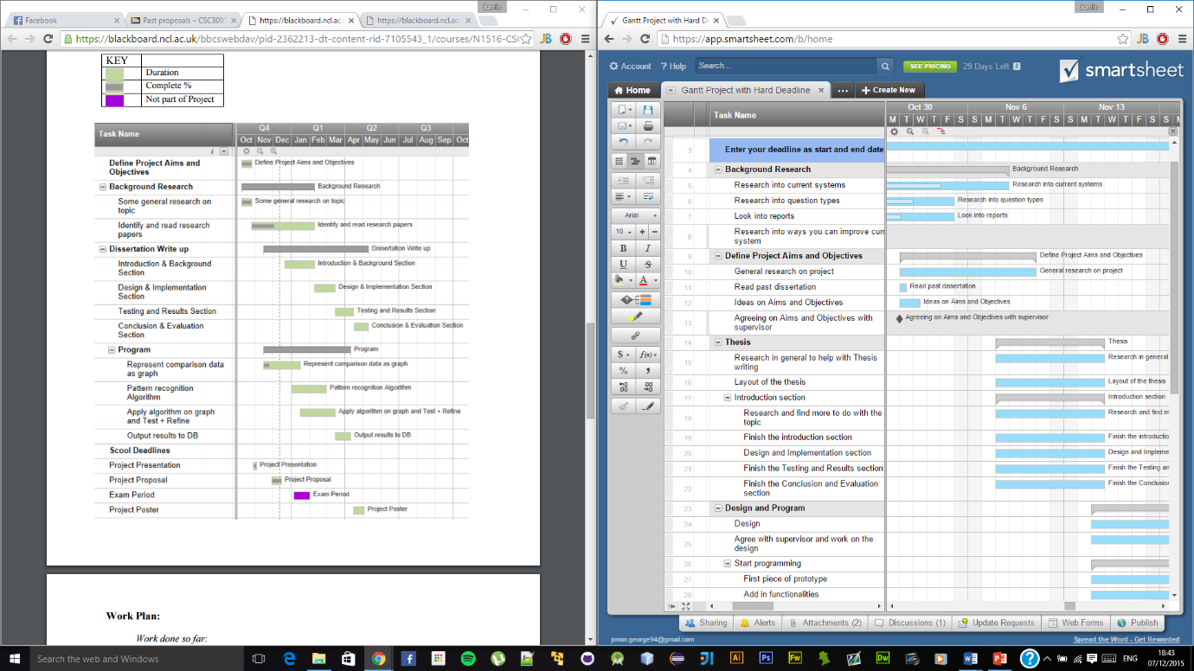Figure 1 shows a snippet of the Gantt chart, showing the work plans that is proposed for this project.

**Figure 1.6:** Gantt chart

## **Project Structure**

Chapter one will be the **Introduction**¸ details the motivation behind this project as well as identifying the current problems within an existing project/area. In addition, within this section it will state the research aims and objectives as well as identifying the importance of the proposed research area.

Chapter two provides **Background Research** which involves in review of a detailed study of the current systems/projects that are available and then analysing each one against this project.

Chapter three will be **Requirement Gathering and Analysis**¸ within this section, there will be a complete analysis of the current system and what the new system will have in order to solve the issue (e.g. functional requirements, non-functional requirements). In addition, this chapter will also include preliminary research (interviews to find what different users found about a system).

Chapter four is **Design** which will present diagrams and datagram models of my system. This will be done by taking reviews of the system design in a detail to ensure that every core aspect of this project has been met.

Chapter five is **Implementation and** **Testing**, within this section it will give an overview of the tasks and process to reach goal of the research. In addition, this chapter will explain and discuss all the implementation decisions that had to be taken for this project, for example the various elements of the language learning course. With the help of this chapter, it will help to identify issues within the new built system. Furthermore, test plan should also be provided.

Finally, Chapter six will be **Evaluation**, provides an overall evaluation on the project based on the evidence gathered and how the project has met the criteria. In addition, this chapter also talks about what possible works can be done in the future for this project.

# **Chapter 2: Background Research**

## **Existing Examination Tools or Products**

There are a variety of Examination products which are designed and implemented to aid the end user to conduct an examination utilising the Internet. By the end of this chapter, it will provide a good amount of information and requirements for a new system. Analysing and evaluating systems which exists currently will help to explain in detail about the implementation and user expectations that has to a system.

### **Respondus**

Respondus offers varies different products such as Respondus 4.0, LockDown Browser, Respondus Monitor and Study Mate (Respondus.com, 2016). All these products have been used for the purpose of assessment in the educational institutes (over 2,000 colleges and universities in over 50 countries uses Respondus to enhance learning system). Respondus works closely with partners and they provide an easy integration with their partners system (e.g. Blackboard, Design Science, Moodle, and Pearson).

Respondus 4.0 is the 4th version of Respondus, it is a windows based application which makes it easier for the end user to create and manage exams for technology partners such as Blackboard Learn, Moodle, Canvas, and other eLearning systems (Version 4.0, 2016). Respondus 4.0 supports up to 15 question types including calculation and algorithmic formatted. Since the end user have access to the Test Bank Network (contains thousands of test banks for leading books in higher education e.g. Pearson) it makes it easier for the examiner to set an exam. Respondus allows the examiner to import questions which are saved on a MS Word, RTF format, and tab/comma delimited format. In addition, Respondus also provides “Spell Check” for an entire exam file which will consists of American English, British English, Dutch, German, French and medical dictionary (Features, 2016). See Appendix A to see every feature that this product offers.

LockDown Browser is a custom browser that Respondus provides for the purpose of assessment. When an assessment starts, students are locked within the browser until they submit their exam for marking. Everything else apart from accessing the browser for carrying out the exam will be locked out and limited to functionality to prevent anyone from cheating. LockDown integrates with most of the well-known eLearning assessment system such as Blackboard, Canvas, Moodle, and Sakai. Assessments are displayed full screen using the browser and cannot minimise or maximise. Copying, pasting, print screen, print, task switching and any other features that operating system provides are all blocked from running (Browser, 2016).

Respondus Monitor is an additional application for LockDown Browser which make use of the webcam and video hardware peripherals to prevent anyone from cheating during an exam. During an online exam, it will automatically notify the examiner if the student has been caught in any way for suspicious behaviour such as taking screenshots, using copy/paste functions or even different person entering the video frame. With the help of this product, it guarantees that right person is taking the test since a video will be monitor from the start of an exam session (Monitor, 2016).

Study Mate is mainly designed to develop the students learning knowledge within a course material. In order to make it collaborative and combined for everyone Respondus designed different types of activities such as self-assessment, games and even learning activities which engages students with the course contents. Crosswords, fill in the blank, fact cards, flash cards and order matching are some of the games that Respondus offers (Respondus, 2016).

### **Moodle Quiz**

Moodle is an eLearning platform which is primarily designed to provide examiner and the learner with a secure and robust system to create and manage learning environment such as exam, making course material available and interact with lecture materials with the use of games/activities provided. (Moodle, 2016).

Moodle Quiz supports different form of questions this includes essay, matching, multiple choices, short answer, true and false and many more. Moodle provides the examiner the control on who can see the quiz, when and how they will be get scored, how feedback will be provided and also statistics to get from an exam. Moodle quiz tools is very powerful and flexible in terms of monitoring and diagnosing the students’ performance. “Chapter check” is an example of feature that Moodle provides to ensure that the student have read and understood a chapter that was told by the examiner/teacher. Creating a little mini test will help to identify how many students in a class has read and understood the material, also most importantly provides the examiner/teacher with data which will show the students’ knowledge within each aspect of the reading material and pin point where each person is doing good or bad(Moodle, 2016).

Since test and quizzes that are set up using Moodle requires outside class work, there is a high chance of people could end up in cheating. However to prevent this from happening Moodle take precautions such as randomising the questions order and also the answer order, timer in place for each question or the entire exam, and also limitation in the number of time a student can take a specified exam. Moodle is now been proven and trusted by worldwide education institutions as well as organisations. Moodle provides scalability to any size, Moodle can be scaled to support a small number of people in class to thousands working for an organisation (Quiz Practices, 2016).

Statistics is an important part of an exam, Moodle ensure that the examiner is given with detailed analysis of how students participated on an exam. There are different variety type of reports that Moodle offers such as Statistic report (analyse the quiz and the questions within it and create a report based on that), Grade report (student’s attempt on an exam and the grade boundaries as well as the option to export the result into selection of formats), and many more (Reports, 2016).

### **Conduct Exam**

Conduct Exam is an online examination system developed by RK Infotech and it provides services to education institution as well as many leading corporation/organisations. Conduct Exam states that their aim is to “help the students as well as the clients to transcend the time constraints and geographical boundaries with highly skilled administrator and monitor” (Conductexam.com, 2016).

Conduct Exam separated their product for two users which are administrator (who has the privilege to create and modify exams) and user (student or client who will be sitting for an exam). Conduct Exam provides the examiner the choice to import questions from word/excel format on to the web based system. It also supports different type of questions including most images, formula related questions, videos and many more. Provides the examiner with detailed statistics of the exam and how students have participated within an exam (e.g. number of students registered for an exam, analytics report on each questions that belongs to an exam and many more reports). Students get their result straight away after submitting the online test since the marking is done automatically with the use of regex that the examiner can specify for each individual questions for an exam. Student are also given the options to see a detailed report showing their performance on an exam. This allows the students to see where they have went wrong and what could they have done to get the question correct for the next time.

Students can take the online test using multiple languages 24/7 from any device since the website is user friendly to any platforms. Study material is another feature that Conduct Exam provides and it allows the students to share study materials with each other and have the ability to download it for their exam preparation. Student have also have the choice to opt-in to a notification which will notify them when any new online test, study materials or results been published.

### **Speed Exam**

Speed Exam is an online examination system, offers services to education institutions, recruitment, manufacturing, banking and also for health care organisations. With the help of Speed Exam it is possible to create an exam just under one minute and communicate with the candidate with the integrated email and SMS system. Offer wide range of question types including drag and match, multiple choice, fill in the blank, essay, vide based question and also calculation based questions.

Exam Monitoring is a premium feature that Speed Exam has implemented within their system which allows the examiner to watch live exams and see current activities of each individual candidates who are taking the exam. It allows examiner to see how many participants have got the questions right so far into the exam, how many of them finished the exam and also live capturing on what each participants currently doing. Speed Exam has tools in place to prevent anyone from having multiple sign-in, copy, paste and print screen. Examiner will be notified instantly with the participants IP address, location and also the browse details used within that incident. All exam related alert are logged and available to review and resolve the alerts at any time by the examiner (admin account).

Analytical reports will be produced after an exam, which will show the examiner overall performance of all the sections within an exam and detailed graphical representation on how well each student found each individual question (Overview, 2016).

Speed exam site is responsive this means it can go really well with any device, be a PC, laptop smartphone or tablet. This will allow the examiner to create an exam from anywhere at any time. Candidate can self-register their self in order to access the website, Speed Exam has checks in place to ensure a proper email verification is made for the candidate to prevent anyone from signup using fake details (e.g. disposable email address).

### **Pro Profs Quiz Maker**

Pro Profs is the last and final product that is currently available to create an engaging quizzes with the use of features that they have provided. They support up to six different question types including, checkboxes, matching, video/audio based, true or false and many more. When adding question, examiner has been given an optional choice to add a note to help explain it to the candidate (e.g. hint). Examiner can rearrange the questions as well as give specific marks for each individual questions. Questions are randomly asked to prevent anyone from cheating. Some of the questions are marked automatically and some are left for the examiner to manually mark it by their self.

Pro Profs offers over 100, 000 ready to use quizzes and questions on any educational or organisational topics (Proprofs.com, 2016). Examiner has a wide range of options available such as specifying the result type (e.g. pass rate should be 40%), order of questions (e.g. examiner can set it to be random so each individual student will see random questions), assign time to each individual questions or the entire exam and many more.

With the advanced analysis, examiner can easily search on the exam result and find whatever they are looking for. This can be from finding what each individual candidate has performed within the exam (i.e. time taken to finish the exam, when the candidate took the exam) to having that ability to see the breakdown summary of each questions (i.e. finding out how many candidate got each questions correct) in different graphical visualisation. With the help of advanced statistics it will provide the examiner with what should be done to improve the candidate’s performance for the next time.

### **Existing Products Summary**

The following table provides a breakdown of all the products that I have covered above and showing what features each of them have to stand-out from one another.

|  |  |  |  |  |  |
| --- | --- | --- | --- | --- | --- |
| Features | Respondus | Moodle Quiz | Conduct Exam | Speed Exam | Pro Profs |
| Different question types | Yes | Yes | Yes | Yes | Yes |
| Fully automated | No | No | Yes | No | No |
| Option to manually mark | Yes | Yes | No | Yes | Yes |
| Marked by students | No | No | No | No | No |
| Password Protection for entering exam (optional) | Yes | Yes | No | Yes | Yes |
| Students can see their result straight after submitting an exam | No | Yes | Yes | No | No |
| Students can see the mark scheme and improve their knowledge for next time | Yes | Yes | Yes | Yes | Yes |
| Live exam monitoring | No | No | No | Yes | No |
| Student self-registration | No | No | No | Yes | Yes |
| Student get notification when new exam or material is added | No | No | Yes | Yes | No |
| Examiner can create sub admins and assign roles | Yes | No | Yes | Yes | Yes |
| Student registration using csv | Yes | Yes | No | No | Yes |
| Option to customise admin and candidate panel | Yes | No | No | Yes | Yes |
| Time limit for each question or entire exam | Yes | Yes | Yes | Yes | Yes |
| Detailed analysis | Yes | Yes | Yes | Yes | Yes |
| Print Reports | Yes | Yes | Yes | Yes | Yes |
| Graphs to support analysis | Yes | No | Yes | Yes | Yes |
| Exam integration with other organisations | Yes | Yes | Yes | Yes | Yes |
| Reports can be exported using different file formats | Yes | Yes | Yes | Yes | Yes |

See Appendix A - Existing product features for detailed feature listing of each products.

## **Graphical Visualisation**

Graphical representation is an effective way of displaying data and statistical reports with the use of different type of graphs such as charts, diagrams, plots and many more (Gale, 2016). One of the main advantage of using Graphs is to have a complete overview of the problem or scenario instead of having to read hundreds of pages to get what is on other people’s mind. Within an instant view it makes it more clearly on the data and more importantly information process make it quicker.

Below there is a list of different type of graphs with detailed explanation on what they are mainly used for. These diagrams will be considered towards to this project, to help examiner and students with a better understanding of the data (e.g. performance of students on an exam).

### **Bar Diagrams**

Bar diagrams are good for showing how data is changed over time. Most common bar diagram is the vertical graph where the independent variables are plotted on the horizontal axis from left to right. With the use of bar graph it makes it easier to analyse the data since the trends on the graphs highlights the data or a pattern much more clearer compared to result displayed on the a table (Africa Geography Blog, 2016). However one of the disadvantage of using bar diagram would be having to add in additional explanation to support the end-user with the graphical visualisation. This is due to the complexity of the graph, when the data gets difficult to show on graph it ends up in this situation.

### **Pie Diagrams**

Pie diagrams are used as an efficient way of showing percentage of proportional of a data. The independent variable is plotted around the pie diagram either a clockwise direction or an anticlockwise direction. When using pie diagrams, it would be best to use around five or six categories. When there are more categories it will then become difficult for the end user to distinguish from one other. This type of graph help the end user with summarising a large data set in a well explained visual form (Geographyfieldwork.com, 2016).

### **Line Diagram**

Line diagrams are used to display data that changes over time. Independent data are on the horizontal axis (e.g. time) and dependent data are on the vertical axis. Line graphs are very useful in terms of showing the trends over a certain period of time and it makes it easier to predict about the result of data which has not yet been provided with (Betterevaluation.org, 2016).

Study shows that graphical representation of data make much more sense and can be understand by anyone (even by an illiterate person) because it doesn’t involve in having to go through line by line of descriptive report to recognise the content.

## **Web Frameworks**

### **PHP Frameworks**

There are many PHP frameworks that are mainly used to structure a system and most importantly to reduce repetitive coding to create dynamic websites. In order to build this project, there should be a clear idea on whether or not to use framework and therefore this part of the research was crucial.

#### **Codeigniter**

Codeigniter is one of the powerful PHP framework with a good documentation, making it to be a popular framework than can be used to build dynamic web applications or sites. (Codeigniter.com, 2016). One of the main advantage of Codeigniter is that it uses MVC (Model-view-controller) which allows great separation between logic and presentation (Paragoncorporation.com, 2016).

Codeigniter provides other useful libraries and packages that are required for creating a dynamic website such as database, email server, session maintains, and further more (EllisLab, 2016).

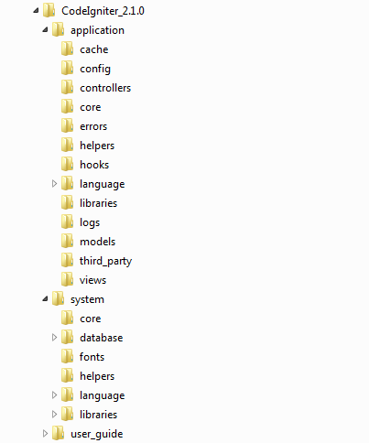

**Figure 2.3.1.1:** shows the directory structure of Codeigniter (3.bp.blogspot.com, 2016)

#### **Zend**

Zend is another popular PHP framework, and is a VC framework as only has view and controller but it doesn’t have a model implementation (Framework.zend.com, 2016). Zend has an extensive validation mechanism in place which can be used to validate data that are getting passed from a form (Bautista, 2010). One of the main advantage of using Zend is that it provides vast amount of libraries and support including user authentication, RSS feed, creating forms, and many more.

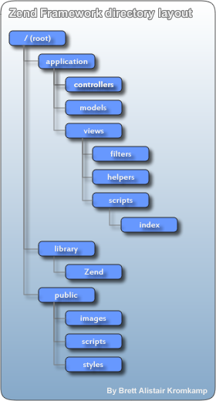

**Figure 2.3.1.2:** shows the directory structure of Zend (Kromkamp, 2016)

#### **Summary of PHP Framework**

For this project after considering all the different PHP framework, decided to just use PHP without any framework due to lack of knowledge within the framework. Learning a new framework would be very advantageous however it is not practical to do so within the time limit. In addition, it will also require me to start from the basics to get a grasp in knowing more about a specific framework.

Building a website system without any framework would be tougher however research shows that novice user who hasn’t had experience of using framework will struggle and find hard to manage work due to the complexity and the time spent to developing the system. Custom coding will work faster than setting up a framework for a small project.

### **Bootstrap**

Bootstrap is most popular front end framework that supports in terms of HTML, CSS, and JavaScript for responsive website (will be compatible to run on any device). In order to use Bootstrap there is not much knowledge needed, anybody with just basic knowledge of HTML and CSS can make a good start on Bootstrap. Bootstrap is now compatible with all browsers including Chrome, Firefox, Internet Explorer and Opera.

One of the main advantage of using Bootstrap is to speed up the development in designing your website with the use of libraries and packages that it offers with. Bootstrap also provides with ready-made theme and modify it based on your needs (W3schools.com, 2016).

## **Possible Technologies**

### **Client Side Scripting**

#### **HTML 5**

HTML 5 is the latest version of HTML (hyper-text mark-up language) used to form a website. Since HTML 5 offers new elements and features in place it makes it easier to integrate multimedia contents on to the web without using any third party plugins (Kirichik, 2016). For this project this is one of the language that will be considered since it offers wide range of APIs which helps to make the user experiences better and having the capability in adding more dynamic contents on to the webpage (e.g. drag and drop, offline storage database).

#### **CSS3**

CSS (Cascading styling sheet) is a powerful style sheet language that is been used to control the look of a website. With the use of CSS it enables the designer to create rules for the HTML elements and apply changes to those (e.g. changing the background colour of the paragraph element). Within CSS3 it contains the old CSS specification as well as newly added in modules such as selectors, text effects, animations, box models and many more (Branded, 2011). CSS can be used to customise pages as well as set the style for each unique element in a webpage. In addition, with the use of CSS it loads the pages up faster compared to having it in the HTML and that is the main use of considering this language for this project.

#### **JavaScript**

Within this project, JavaScript would be reflected due to the extended functionality that it can offer to a website. Since JavaScript runs on the client side it is very fast because the function can be run instantly without having to wait for a server response. JavaScript uses the DOM (document object module) which provides wide range of functionalities that could be used on a website (Jscripters.com, 2016).

#### **JQuery**

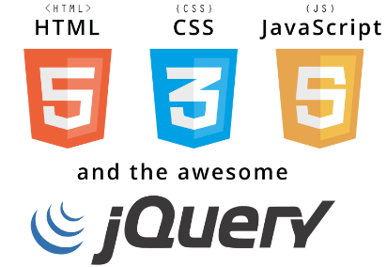Jquery is an extended library for JavaScript that makes it easier simplified syntax code for Javascript to take care of. Developer doesn’t need that much knowledge within the field to understand and get to know how to use Jquery since there is a lot of tutorials and documentation is available. Compared to other libraries JavaScript could use to make something that can be done with less lines of code in Jquery (Jscripters.com, 2016).

**Figure 2.4.1.4:** shows an icon of HTML5, CSS3, JavaScript and Jquery (Seoclerks.com, 2016)

### **Server Side Scripting**

#### **PHP**

PHP is one of the server side scripting language to be considered for this project, it is open source and been used widely across the globe. PHP can be used for server side scripting, command line scripting and also to write applications. PHP goes really good with HTML and not much knowledge in the language is necessary to get start with using PHP. With the use of PHP, it allows to interact with the user visiting on a website with the use of contact forms, shopping basket, live chat, any many other interesting features (Php.net, 2016). PHP is a well-known language and once you know the basic, then there is a lot of resources available on the internet that can be used to meet the developer or designer needs.

#### **ASP.Net**

ASP.Net is an application framework used to build dynamic web pages. ASP.Net is a Microsoft application that is compiled other languages such as Visual Basic and C#. One of the main advantage of using ASP.Net is that, it includes all the class libraries that are built by Microsoft. In most of the examples, it shows that this server side scripting language has been used in larger projects compared to small project due to the amount of code you have to write (ASP.Net reduces the amount of code required to build larger applications). In addition, it comes with a huge collection of server and client side controls that can be used to develop interactive and collaborative calendars, wizards and many more (www.tutorialspoint.com, 2016).

#### **Summary of Server side Scripting**

To conclude on server side scripting, this project will be using PHP as it is open source and it provides the most cost free solution. Also PHP will provide large amount of resources and support for this project since there is a huge amount of tutorials and guidelines online. Research shows that PHP is used by 82.3% website compared to 15.7% who uses ASP.Net (W3techs.com, 2016). In comparison with ASP.Net, PHP is more simplistic to learn and with a good basic understanding in the language would help to gain more knowledge. However in the other hand ASP.Net will require more time and knowledge.

PHP can also be used to have a good level of security if SSL (Secure socket layer) is enabled to make the website secured. PHP has many other extensions such as SSL, XML, SQL and many more. IN addition, PHP gives the capability to work with other interfaces, giving the developer the control to build the website on how ever they want it to be.

**Figure 2.4.2.3:** shows comparison image of ASP.net and PHP (Orientsoftware.net, 2016)

## **Version Control**

Version Control is a system that is been used throughout the project to help with recording changes to a file or a set of files over period time. This will help the developer with backing-up and also retrieving files that were reordered in the past. One of the main advantage of using Version Control in a project is to ensure that you have a recovery option if in case files are lost, they can be easily recovered (Git-scm.com, 2016). Throughout this project, GitHub will be used as VCS due to its increasing popularity and the flexibility in using it. GitHub provides free service long as the project is open source however there is payment is involved if the project is set to be private. One of the main benefit of using GitHub these days is to show others what projects you have done with clear details on when and how long you have worked on a project.

## **Database**

### **MySQL**

MySQL is an open source database management system (DBMS) used to store and retrieve data as well as for organising data which are already stored. MySQL runs pretty much on all the platforms including Linux, Windows and UNIX. It is mainly been used for web-based application and used widely, therefore lot of resources are available to support (Mysql.com, 2016). One of the main advantage of using MySQL is that it is very easy to use, only require basic SQL knowledge and relational database content is similar like on SQL. Security is a big factor when it comes to database, MySQL provides solid security in place that protects sensitive information and this can be done using wide range of mechanism such as hashing methods, MD5, and many more.

### **PostgreSQL**

Postgresql is a relational database management system (RDBMS) which is similar to MySQL. It is also open source and be used within a programming language such as PHP. This DBMS is mainly used for complex database design, used mainly to store geographical data. Compared to other RDBMS, Postgresql provides the best functionality and possibilities without “giving up on the valuable assets” (Digitalocean.com, 2016).

### **Summary of Database**

MySQL is the database that will be chosen for this project, because of having the knowledge and experience with using that language throughout the modules that has been taught at University. Furthermore, MySQL is faster than Postgresql and it will be ideal for this project, as there will be a large amount of data to be stored and processed on the database. MySQL is scalable, it can handle almost any amount of data and process of retrieving data is faster compared to other DBMS. MySQL also supports many of the development interfaces such as JDBC, ODBC, and many more.

## **Methodology**

One of the main component of a successful project includes in choosing the suitable and reliable methodology. The project has to go through different phases of the life-cycle including planning, gathering requirements, implementing, testing and maintenance. There are different software development methodologies that are suitable for this project (Kumar, 2005).

### **Agile Methodology**

Agile methodology is based on a recursive and incremental development. This methodology requires frequent review and adaptation to the project in order to ensure that it meets the requirements. These would be the lifecycle phases if this project were to follow the agile process: planning, system analysis, implementation, testing and maintenance. (Agilemethodology.org, 2016). In addition, agile methodology is repetitive and iterative. Most of the companies adopt this lifecycle method and it is ideal since you always ensure that you meet the client’s requirements and if not then adapt all necessary changes.

### **Waterfall Model**

Waterfall model uses a downward motion, this means that progress are made from the start of the methodology phases and going through one after one in a clear and chronological order. One of the main advantage of using this methodology is that, every phases has a start and an end, at each stage the project can be re-designed in order to meet the requirements. In addition, this methodology is very flexible since the user has the ability to go back to any stages to modify something and make changes to the project at any time.

However a downside to this methodology is that, if the customer or client doesn’t know what the project is at the start then this can be a problem as the design might be too expensive to implement. This could result in re-designing where time loss and destruction of information. Furthermore, once at the testing stage, it will be very difficult to go back and change something that was not well thought out at the start, this can lead into cost and also time. There are examples of project that resulted in stopping due to not having a clear plan from the start of the methodology process.

### **Summary of Methodology**

For this project, Waterfall is the ideal methodology since the structure of the methodology make it easier as it follows a steadily downward pattern. In waterfall, any modification would result in all the stages of the life cycle to be repeated. Therefore upfront from planning of the project, ensure that there is no need to go back to a process.

Since there is a clear guidelines on what this project has to be done it will be fine using this methodology however if there was no clear instruction then it could lead to budget overrun and can be inadaptable. Also from the start of the project, all the necessary planning will be taken care to avoid having to repeat the phases from the start again which can be time consuming as well as costly.

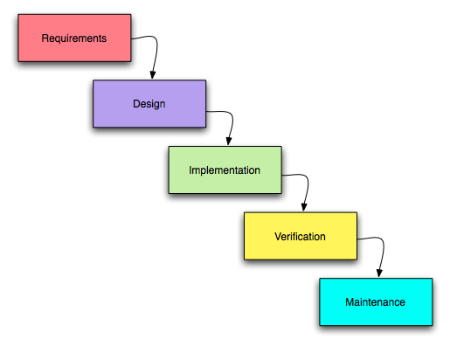

**Figure 2.7.3:** Waterfall Model (Umsl.edu, 2016)

# **Chapter 3: Requirement Gathering and Analysis**

## **Introduction**

This chapter will be used to gather requirements and analyse techniques that can be helpful towards to this project. One of the key deliverable of the system is a fully functional website which will be designed both for examiner and student. Within this chapter, it will help to classify all the requirements for the system and identify the main functionalities required.

## **Preliminary Research**

### **Interviews**

Interview was one of the method used for collecting data for the proposed system. Interview were conducted with five users to get further clarification of the prototype system requirements.

Within the interview, several topics were discussed, including requirements to the system, what existing system has in place and what they would like to see in the new system. Discussed about what features should be added into the system to make it more user-friendly and also to meet the requirements.

Mr. Wild is an ICT teacher at North Tyneside Learning Centre, Newcastle. He is highly computer literate and mainly teach kids at the age from 4 to 13 on programming, this includes Python, Minecraft hacking and many more interesting concepts. From an examiner side of view, Mr. Wild suggested several ideas that he would expect to see on a mock examination system including different statistical reports on how well the student is performing (e.g. showing how well they have done on each exam that they have participated on) and many more.

One of the main suggestion from this interviewer was “I want students to self-mark their own mock exam at the end based on the mark scheme that I will be providing for each questions. This way I know what their understanding for each question, also most importantly if they actually understood the mark scheme for each specific question”.

For the full detail about what is discussed in the interview, see Appendix B - Preliminary Research, for the interview transcript.

### **Questionnaires**

Questionnaire was one of the other method that I have used to collect data. Around twenty two people participated on the questionnaire in order to get a better understanding on what the end user will like on a mock examination system. Reason for doing questionnaire is to discover what features and techniques that should be added into the new system and how the user thinks about the current features. Also within the questionnaire, there are some open-ended question to let the user provide some suggestions or ideas for the features that could be implemented if it is see as a potential idea.

Results from the questionnaire shows that majority of the candidates who took participated in the questionnaire uses “online mock exam” as a resource to prepare their-self for an exam. Below there are some statistics gathered from the questionnaire.

**Figure 3.2.2.1:** statistics showing if student likes to save the exam as a PDF or have the option to view it after an exam.

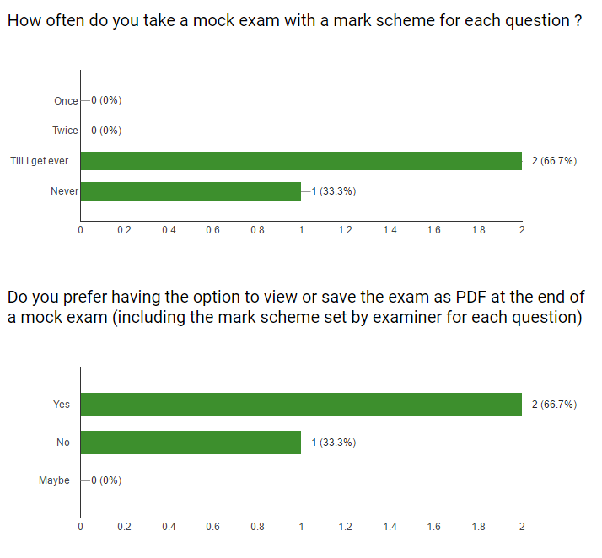

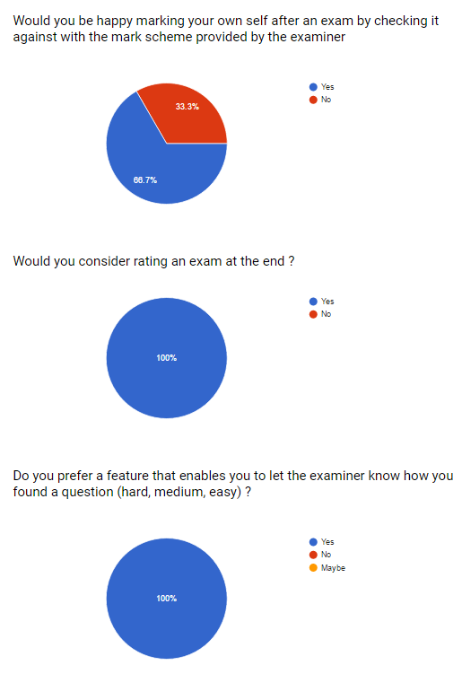

**Figure 3.2.2.2:** statistics showing if student would agree with the idea of letting the examiner show how they found a question (hard, medium, and easy).

For the full detail about the questionnaire results and questions been asked, see Appendix B – Preliminary Research, for the questionnaire results.

## **Client Requirements**

### **Functional Requirements**

|  |  |  |  |
| --- | --- | --- | --- |
|  | Requirement | Priority | Comment |
| 1 | There should be two distinct user type for this system, which is student and examiner | High | This should be a high priority since it distinguish between the two important user types |
| 2 | User should be able to register their self on to the system | High | This is set to be high since it’s a requirement that should be available always to keep the service to the end user |
| 3 | User should be able to login | High | User can login after a successful email activation |
| 4 | User should be able to reset password if forgotten | Medium | No comment |
| 5 | User should be able to access about, FAQ, and contact without having to login | Medium | No comment |
| 6 | User should be able to change their profile details such as changing pictures, contact details, personal details and many more | Medium | Only possible after successful login to the system. |
| 7 | User should be able to log out of the system without any problem | Medium | No comment |
| 8 | User should be able to access and enter any exams that are currently set to be active and available. | High | If the examiner has an exam to be available then it should be accessible to the each individual student otherwise stated. |
| 9 | User should be able to see the timer, questions remaining, total questions and also the exam details before or while they are in an exam. | High | All these should be provided within the system |
| 10 | User should be able submit before an exam at any point during the exam | Medium | No comment |
| 11 | User should be able to see their each individual exam attempt reports | High | Soon as user attempts an exam, it will become available on their summary page |
| 12 | User should be able to see their answer as well as the correct answer set by the examiner for each exam on the summary page | High | User should be able to see their answer and the correct answer set by the examiner for each exam. |
| 13 | User can save the result as PDF, or view the attempted exam at any time | High | No comment |
| 14 | User should be able to mark their own self by checking boxes to the questions they believe they got it correct | High | Exam mark will be pending till the student marks their self. |
| 15 | User should be able to rate the entire exam | High | This is vital because it gives statistical report to the examiner on how well each student found the exam |
| 16 | User should be able to rate how they found each question on an exam | High | Again this important, valuable information that will be passed to the examiner, pointing out which questions are hard and which ones are easy. |
| 17 | User should be able to access the website and also access the available exams at anytime from anywhere | High | No comment |
| 18 | Admin part of the website is only accessible by an admin user account type | High | Students are not allowed to see admin side of the website and only accessible by the admin user type. |
| 19 | Examiner should be able to see how many users are registered, and how many of them are currently online. | Medium | No comment |
| 20 | Examiner should be able to see the current active exams | Medium | No comment |
| 21 | Examiner should be able to see how many people have participated in each of the exam that was set by the examiner | High | No comment |
| 22 | Examiner should be able to add or modify categories which are used to group an exam | High | No comment |
| 23 | Examiner should be able to create and modify any exams that are currently recorded on the admin panel | High | No comment |
| 24 | Examiner should be able to change the status of the exam, duration of the exam, name, and category that the exam belong to | High | No comment |
| 25 | Examiner should be able to use different question types to create an exam | High | No comment |
| 26 | Examiner can specify the correct answer for each individual question inside an exam | High | This is important since these will be given to students after they take an exam |
| 27 | Examiner should be able to see the result of each student, with breakdown of what they have gained and the classification they have scored | Medium | No comment |
| 28 | Examiner should be able to see the breakdown of each exams showing how many students got a question correct, mark classification, rating for the exam, and most importantly the rating to tell how they found each question in an exam. | High | This will give the examiner lot of information and will be useful. |
| 29 | Examiner should be able to at any point remove or freeze user accounts | Medium | No comment |
| 30 | Examiner can access the admin panel at anytime from anywhere. | High | No comment |

### **Non-Functional Requirements**

|  |  |  |  |
| --- | --- | --- | --- |
|  | Requirement | Priority | Comment |
| 1 | Web-based platform should be easy to use and provide simplified interface that can be used by a novice and advanced user. | High | This requirement should be given a high priority since it’s the fundamental base of the project. |
| 2 | All the functionality should be met as how the requirement from chapter 1 | High | No comment |
| 3 | Application should be robust and have checks in place to ensure there are no errors can possibly occur during an exam | High | No comment |
| 4 | Student should only see their own data not anyone else’s results because privacy does matter | Medium | No comment |
| 5 | Usability is very important and will have research and testing in place before and after the development stages. | High | No comment |
| 6 | Maintainability is crucial to a project and therefore documenting codes as well as detailed explanation of what is been done and what can be done to improve it | High | No comment |
| 7 | In terms of portability, this project should be following the latest packages and API and will ensure that it is portable | Medium | No comment |
| 8 | Database should be reliable since it holds all the information of the users and admin | High | No comment |
| 9 | When user starts an exam the timer should be accurate and no errors should occur. Performance of the website is very vital and should do all the necessary overcomes | High | No comment |

## **Use Case**

From what is been gathered, came up with some mock-ups of how the web-based application will look. This design below shows a preview of how the examiner would be setting up an exam with the help of different question types and quiz settings.

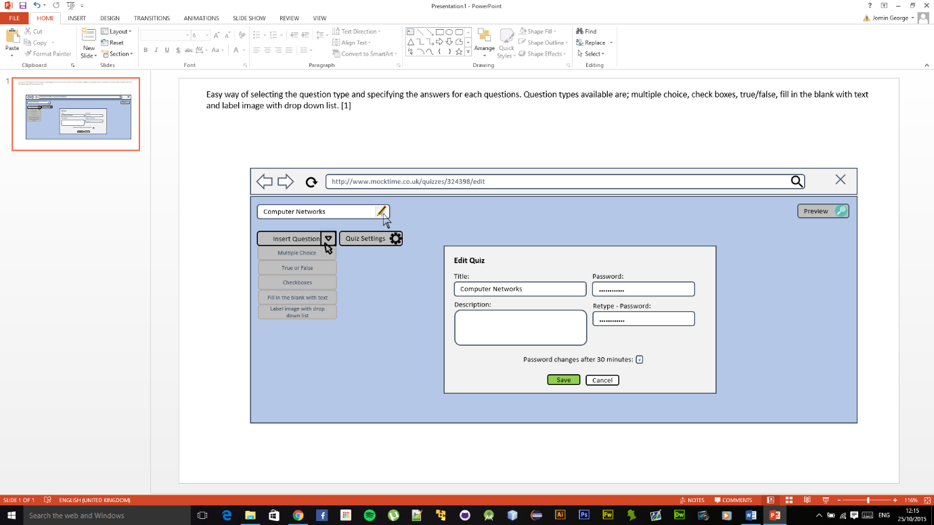

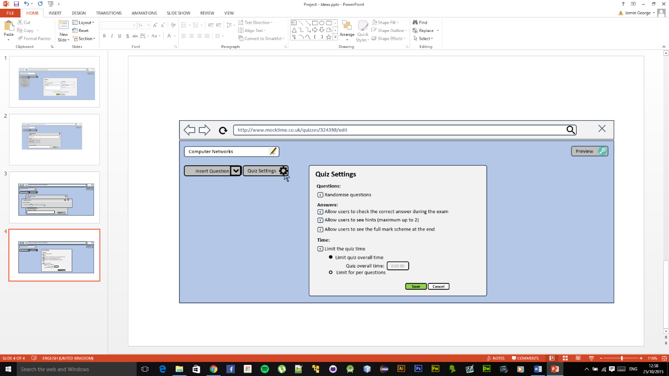

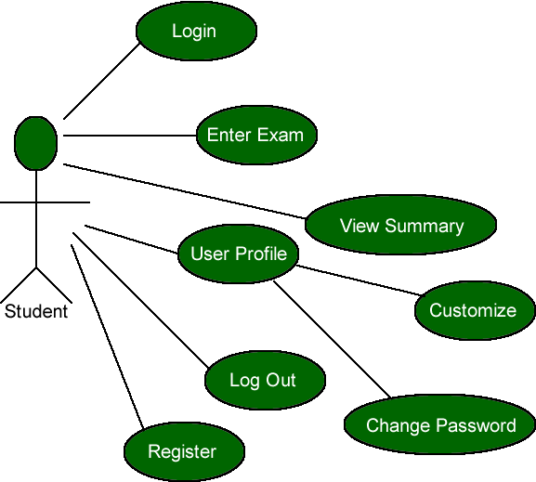

**Figure 3.4.1:** shows the use case for Student

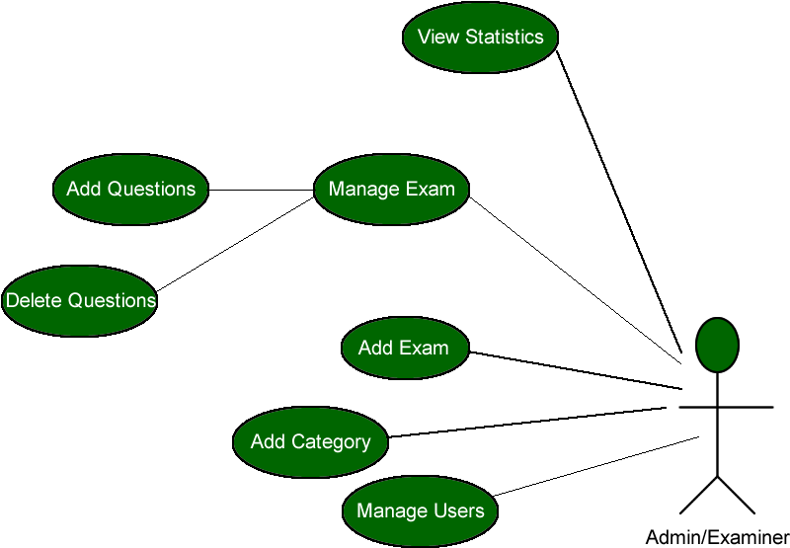

**Figure 3.4.2:** shows the use case for Admin

Use case specifications are always the best way of describing how the system will be used. From a use case specification, identify what are the things that could possibly go wrong. Finding those problems could help the project from saving a lot of time and free from problems.

**Log In/Register (Student and Admin)**

**Description of this case :** Let the student or register their-self with the system

**Precondition** : User must not be logged into the system

Go to Login Page

Existing User?

No

Register

Yes

Login

**Profile Details (Student and Admin)**

**Description of this case :** Let the student update or view their personal details, as well

an option to set a profile picture.

**Precondition** : User must be logged into the system

Select User Profile

View Profile

Update?

No

Yes

Yes

Update profile

Any errors?

No

**Change Password (Student and Admin)**

**Description of this case :** Let the student change their password

**Precondition** : User must be logged into the system

Password Changed

Select Change Password

Yes

Submit for validation

Anny errors?

No

**Enter Exam (Student)**

**Description of this case :** Let the student enter an exam which is currently available

**Precondition** : User must be logged into the system and exam is active

Select the exam

Start Exam

Submission?

No

Exam Completed

**Add Exam (Admin)**

**Description of this case :** Let the admin add an exam

**Precondition** : Admin must be logged into the system

Add an exam

Errors

Submit data

No error

Exam added

**Add/Delete/Edit Questions into an Exam (Admin)**

**Description of this case :** Let the admin add questions into an exam

**Precondition** : Admin must be logged into the system

Select exam

Add/Delete/Edit questions

Submit data

Validation failed

No errors

Successfully done

**Deleting an Exam (Admin)**

**Description of this case :** Let the admin delete an exam

**Precondition** : Admin must be logged into the system

Select exam to delete

No

Delete?

Yes

Deleted successfully

# **Chapter 4: Design**

## **Introduction**

This chapter will provide an insight into the end application ways in how to improve it before the project reaches to the implementation phase. Within this phase, it will help to identify how the system should be built and how the system will function in terms of hardware and most importantly the user interface (Eternal Sunshine of the IS Mind, 2013). Within this chapter, it will clearly designate the strategies which are in place to handle exceptions as well as any issues related to accessibility.

## **Database**

### **Database Schema**

Within this section of the Design chapter, will provide information about the database and what tables are there holding information about the data. For this project, all the tables and database design related matter has been dealt with using MySQL.

|  |  |
| --- | --- |
| Table Name | Data Fields |
| Mock_exam_answers | {answer_id (Primary Key), question_id (Foreign Key), answer_name, is_true} |
| Mock_exam_category | {category_id (Primary Key), category_name, status, date_created} |
| Mock_exam_faq | {faq_id (Primary Key), faq_question, faq_answer, faq_date_updated} |
| Mock_exam_questions | {question_id (Primary Key), question_name, question_type, quiz_id (Foreign Key)} |
| Mock_exam_quiz | {quiz_id (Primary Key), quiz_name, quiz_category_id, quiz_duration, total_questions, quiz_status, quiz_password_required, quiz_secret_password, date_created} |
| Mock_exam_student_result | {student_result_id (Primary Key), student_summary_id (Foreign Key), user_id (Foreign Key), exam_id (Foreign Key), question_id (Foreign Key), student_answer, student_result_status, difficulty_level} |
| Mock_exam_student_summary | {student_summary_id (Primary Key), exam_id (Foreign Key), user_id (Foreign Key), category_id (Foreign Key), exam_result_status, time_taken, star_rating, student_result, exam_start_time, exam_end_time} |
| Mock_exam_users | {user_id (Primary Key), email_address, password, firs_name, last_name, email_code, lastSeen, profile_picture, freeze_account, active_status, date_created, password_recover, user_type, admin_password_check, session_start} |

**Figure 4.2.1:** shows the tables that will be storing all the data related to this project

Answers – this table stores all the answers related to a question and states which one is the correct answer if there is more than one answer for a question. This table will require the question_id from questions table as well as a check to which one of the answer is the correct one for a question since there could be more than one answer can be provided by the examiner.

Category – this table holds information about a category that can be used when setting up an exam. There is also a field within this table that allows the user to set the status to be true or false, making it become available to use anywhere else.

FAQ – this table holds information about frequently asked questions, including the faq_question, faq_answer and when the last time it was modified was.

Questions – this table holds all the questions for every exam that has been created by the examiner. It will show each questions, question type as well as the field pointing out which exam it is related to.

Quiz – this table shows information that is necessary for an exam. Includes information such as the quiz name, quiz duration, total number of questions, quiz status (to make it available to students), and also password protection.

Student Result – this table will hold all information about each user’s result that they have gained per exam. It also contains information such as the difficulty level of a question rated by each user for each question from an exam.

Student Summary – this table holds all information that is related to an exam and user. It will show the exam details, user details as well as extra fields such as when the user took the exam, how long did they spent, what did the student scored, and also star rating for the exam rated by the student.

Users – this table holds information of all registered users within the system. This includes information such as name, email address, password, profile picture and many more.

### **Normalization**

When creating database, normalization is a process that allows to organize and design database to reduce the data redundancy. Normalization sometimes have the effect of creating duplicated data. During the process of normalization it should be removed without breaking the data integrity rule in place (http://searchsqlserver.techtarget.com/, 2016). Main benefit of using normalization is so that one change can be made and it will be instantly be cascaded out with all the tables related to a specific record.

### **Entity Relationship Diagram**

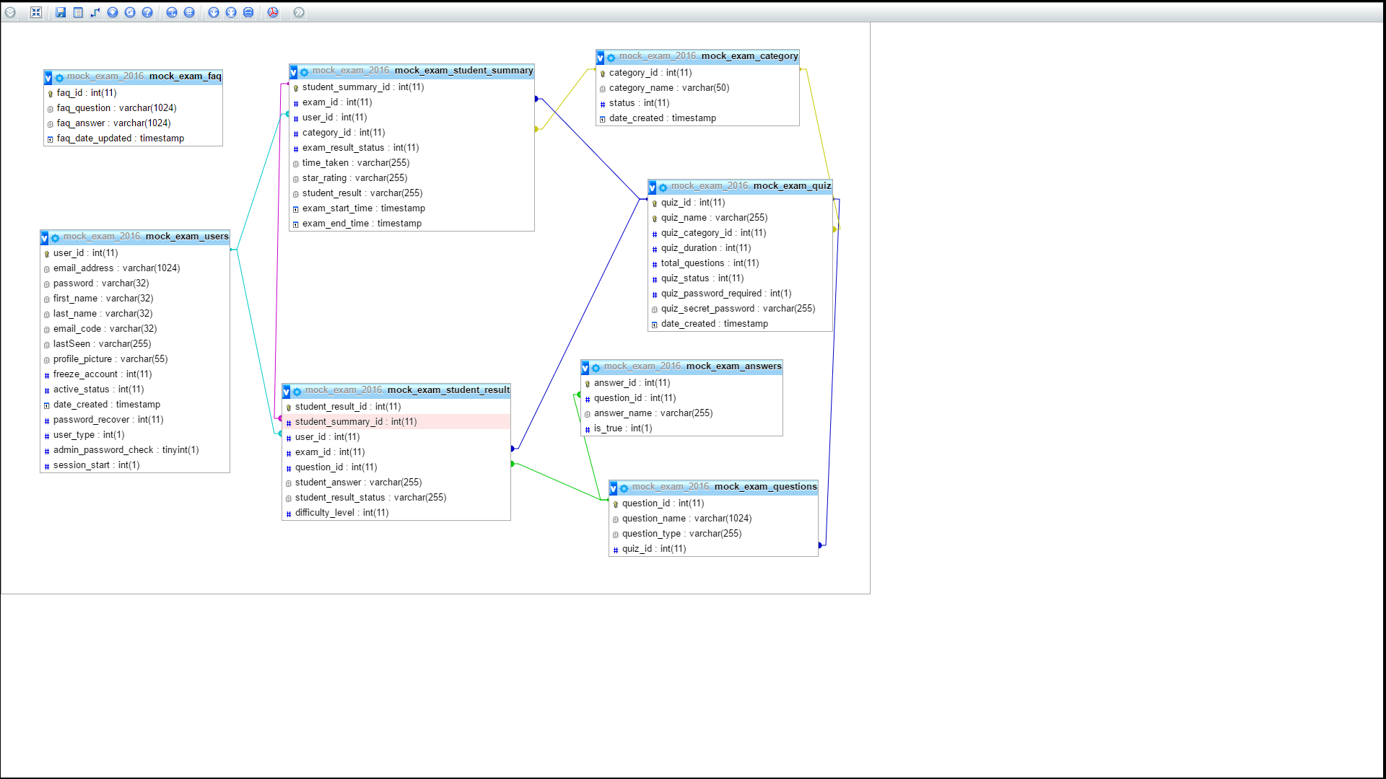

**Figure 4.2.3:** shows the entity relationship diagram

Figure 4.2.3 shows the entity relation diagram that is designed for this web-based mock examination system. ER-Diagram are the best tool used to communicate with the entire database including all the tables and its fields. With the use of ER-Diagram it provides the database designer with information on how the data is flowing within a system and make decisions based on it (Sidana and Sidana, 2016).

### **Integrity Constraints**

Each of the tables in the database if related together with the use of Primary Key and Foreign Key. A primary key is used in a table to uniquely identify each record. So for example, primary key for the Users table would be user_id since it will be lot easier to find a record by looking up its user id instead of a user’s name. A foreign key is a primary key from another table. For example, in Answers table, there is a foreign key been used to identify which answer belongs which question.

## **Web Interface**

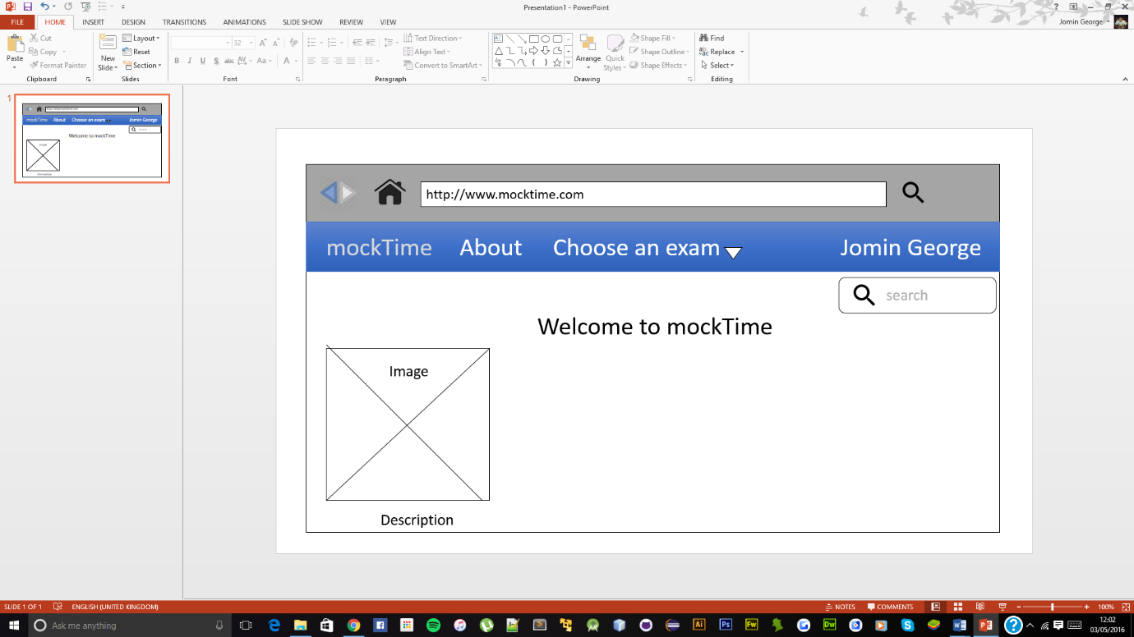

**Figure 4.3:** shows a rough design after student logged in

Figure 4.3 shows a rough sketch of the home page after the user is logged in. As shown above in the figure, it will contain a navigation bad at the top, logo, images and descriptions. To enter an exam all the exams which are available will be populated within the drop down menu from “choose an exam” tab.

### **Navigation**

Home page will be designed by using the all in one strategy so the user can scroll or click on the tabs at the top of page to take them to specific content relates to it. Navigation will be available at the top of every page and it will contain all the links to pages which can be accessed by the user privilege (student’s won’t have permission to access admin related contents). One of the main reason for having a navigation on a website is to make it easy for the audience to access and also for interactive purposes.

### **CSS**

CSS will be used throughout the project for this web-based project. Use of CSS can attract users as well as provide a good impression to the user about the website. For this project, Bootstrap will be used to help out with design and also to save time.

## **System Overview**

### **User Registration**

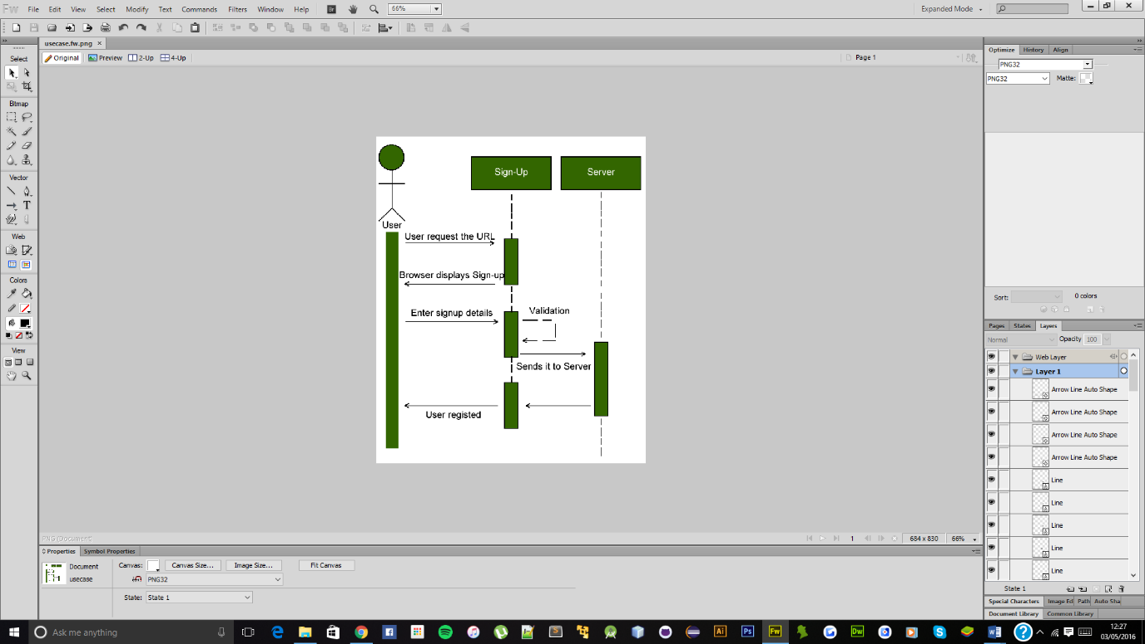

**Figure 4.4.1:** shows the process of registering a user on the system

### **User Login**

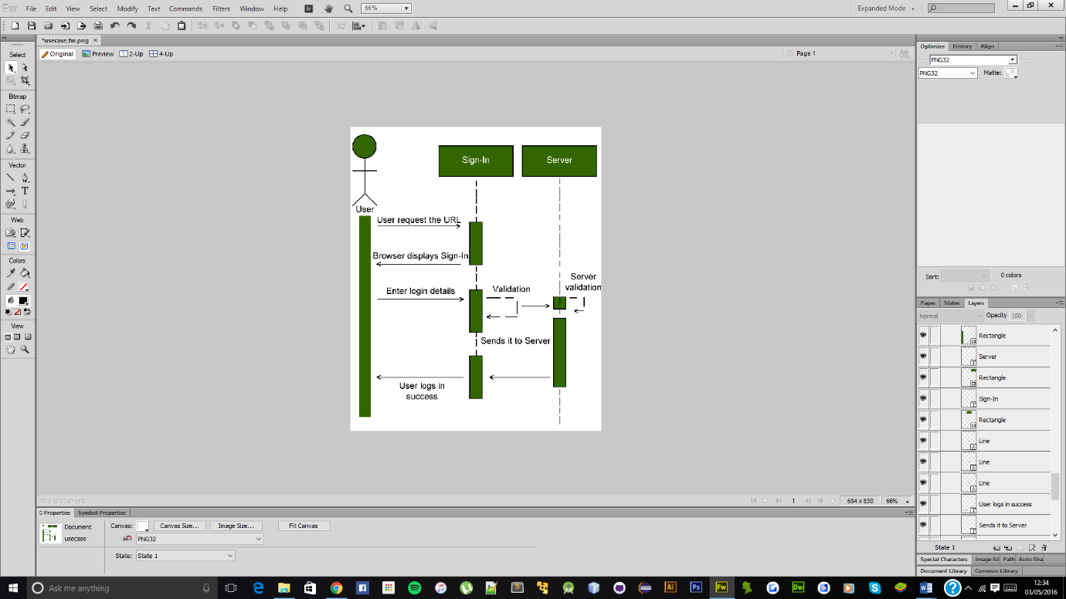

**Figure 4.4.2:** shows the process of user logging into the system

### **User Entering an Exam**

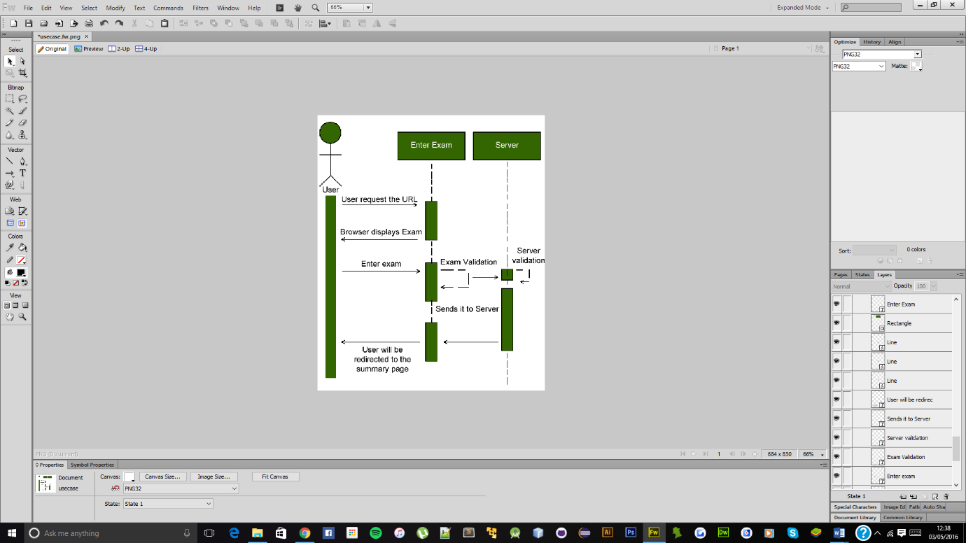

**Figure 4.4.3:** shows the process of user entering an exam and redirected at the end to the summary page

# **Chapter 5: Implementation and Testing**

# **Chapter 6: Evaluation**

# **Bibliography**

### **Websites**

1. Tests, O. (2012). Tech Blogs by BIS.: Online Exam System: The Future of All Examinations and Tests. [online] Blog.softwarehouse.co.

Available at: <http://blog.softwarehouse.co/2012/05/online-exam-system-future-of-all.html> [Accessed 03 Feb. 2016].

1. Busch, B. (2015). Practice makes perfect: why mock exams are great for students’ brains. [Online] the Guardian.

Available at: <http://www.theguardian.com/teacher-network/2015/dec/03/practice-makes-perfect-why-mock-exams-students-brains> [Accessed 03 Feb. 2016].

1. Nhs.uk. (2016). Coping with exam stress - Stress, anxiety and depression - NHS Choices. [online]

Available at: <http://www.nhs.uk/conditions/stress-anxiety-depression/pages/coping-with-exam-stress.aspx> [Accessed 03 Feb. 2016].

1. Respondus.com. (2016). Respondus. [online]

Available at: <https://www.respondus.com/> [Accessed 03 Feb. 2016].

1. Version 4.0, R. (2016). Instructor Quick Start Guide. [online] Respondus® Version 4.0. Available at: <https://www.respondus.com/downloads/RespondusQuickStartGuide.pdf> [Accessed 03 Feb. 2016].
2. Features, R. (2016). Respondus 4.0: Exam Authoring Tool. [online] Respondus.com. Available at: <https://www.respondus.com/products/respondus/#1> [Accessed 03 Feb. 2016].
3. Browser, L. (2016). LockDown Browser. [online] Respondus.com. Available at: <https://www.respondus.com/products/lockdown-browser/> [Accessed 03 Feb. 2016].
4. Monitor, R. (2016). Respondus Monitor. [online] Respondus.com. Available at: <http://www.respondus.com/products/monitor/> [Accessed 03 Feb. 2016].
5. Respondus, S. (2016). StudyMate: Learning Activities and Games. [online] Respondus.com. Available at: http://www.respondus.com/products/studymate/ [Accessed 03 Feb. 2016].
6. Moodle, A. (2016). About Moodle - MoodleDocs. [online] Docs.moodle.org. Available at: <https://docs.moodle.org/30/en/About_Moodle> [Accessed 03 Feb. 2016].
7. Moodle, L. (2016). Quizzes in Moodle. [online] Lti.lse.ac.uk. Available at: <http://lti.lse.ac.uk/moodle/quizzes.php> [Accessed 03 Feb. 2016].
8. Quiz Practices, E. (2016). Effective quiz practices - MoodleDocs. [online] Docs.moodle.org. Available at: <https://docs.moodle.org/30/en/Effective_quiz_practices#Quiz_strategies> [Accessed 03 Feb. 2016].
9. Reports, Q. (2016). Quiz reports - MoodleDocs. [online] Docs.moodle.org. Available at: <https://docs.moodle.org/23/en/Quiz_reports> [Accessed 03 Feb. 2016].
10. Conductexam.com. (2016). Integrated online platform to conduct exams. [online] Available at: <http://www.conductexam.com/Online-Exam-System-About-Us> [Accessed 03 Feb. 2016].
11. Overview, S. (2016). Online Exam Software,Free Test Maker,Quiz Maker. [online] Speedexam.net. Available at: <http://speedexam.net/exam-management-overview.html> [Accessed 03 Feb. 2016].
12. Proprofs.com. (2016). ProProfs Quiz Maker - Create Online Quizzes, Online Testing, Exams.. [online] Available at: <http://www.proprofs.com/quiz-school/> [Accessed 03 Feb. 2016].
13. Gale, T. (2016). Graphic Presentation – FREE Graphic Presentation information | Encyclopedia.com: Find Graphic Presentation research. [online] Encyclopedia.com. Available at: <http://www.encyclopedia.com/doc/1G2-3045000481.html> [Accessed 03 Feb. 2016].
14. Africa Geography Blog. (2016). [Blog] ADVANTAGES AND DISADVANTAGES OF BAR GRAPH. Available at: <http://geographymaterials.blogspot.co.uk/2015/08/advantages-and-disadvantages-of-bar.html> [Accessed 03 Feb. 2016].
15. Geographyfieldwork.com. (2016). Data Presentation: Pie Charts. [online] Available at: <http://geographyfieldwork.com/DataPresentationPieCharts.htm> [Accessed 03 Feb. 2016].
16. Betterevaluation.org. (2016). Line Graph | Better Evaluation. [online] Available at: <http://betterevaluation.org/evaluation-options/LineGraph> [Accessed 03 Feb. 2016].
17. Codeigniter.com. (2016). CodeIgniter Web Framework. [online] Available at: <https://www.codeigniter.com/> [Accessed 03 Feb. 2016].
18. Paragoncorporation.com. (2016). Separation of Business Logic from Presentation Logic in Web Applications (ASP.NET and PHP). [online] Available at: <http://www.paragoncorporation.com/ArticleDetail.aspx?ArticleID=21> [Accessed 03 Feb. 2016].
19. EllisLab, I. (2016). CodeIgniter / EllisLab. [online] Ellislab.com. Available at: <https://ellislab.com/codeigniter> [Accessed 03 Feb. 2016].
20. Directory Structure, P. (2016). [online] 3.bp.blogspot.com. Available at: <http://3.bp.blogspot.com/-Dhk-FfFBzP0/UC_MOCsPK0I/AAAAAAAAABw/o_P4T69G7xE/s1600/codeigniter_directory.png> [Accessed 03 Feb. 2016].
21. Bautista, N. (2010). 10 Compelling Reasons to Use Zend Framework. [online] Code Envato Tuts+. Available at: <http://code.tutsplus.com/tutorials/10-compelling-reasons-to-use-zend-framework--net-12214> [Accessed 03 Feb. 2016].
22. Kromkamp, B. (2016). [online] Quesucede.com. Available at: <http://www.quesucede.com/public/resources/zend-framework/images/zend_directory_structure.png> [Accessed 03 Feb. 2016].
23. W3school.com. (2016), Bootstrap Get Started. [online] Available at: <http://www.w3school.com/bootstrap/bootstrap_get_started.asp> [Accessed 03 Feb. 2016].
24. Kirichik, R. (2016). Top 5 Benefits of Using HTML5. [online] Burningflameinteractive.com. Available at: <http://www.burningflameinteractive.com/aj-burning-flame-blog/top-5-benefits-of-using-html5> [Accessed 03 Feb 2016].
25. Branded, P. (2011). Why Use CSS in Website Design. [online] Purely Branded New. Available at: <http://www.purelybranded.com/notes/why-use-css-in-website-design/> [Accessed 03 Feb 2016].
26. Jscripters.com. (2016). Javascript Advantages And Disadvantages | JScripters.com: developing a site with Javascript. [online] Available at: <http://www.jscripters.com/javascript-advantages-and-disadvantages/> [Accessed 03 Feb 2016].
27. Jscripters.com. (2016). Jquery Disadvantages And Advantages | JScripters.com: developing a site with Javascript. [online] Available at: <http://www.jscripters.com/jquery-disadvantages-and-advantages/> [Accessed 03 Feb 2016].
28. Seoclerks.com. (2016). [online] Available at: <https://www.seoclerks.com/pics/432418-1AQIQV1456360803.png> [Accessed 03 Feb 2016].
29. www.tutorialspoint.com. (2016). ASP.NET - Introduction. [online] Available at: <http://www.tutorialspoint.com/asp.net/asp.net_introduction.htm> [Accessed 03 Feb 2016].
30. Php.net. (2016). PHP: What is PHP? - Manual. [online] Available at: <http://php.net/manual/en/intro-whatis.php> [Accessed 03 Feb 2016].
31. W3techs.com. (2016). Usage Statistics and Market Share of Server-side Programming Languages for Websites, May 2016. [online] Available at: <http://w3techs.com/technologies/overview/programming_language/all> [Accessed 03 Feb 2016].
32. Orientsoftware.net. (2016). [online] Available at: <http://www.orientsoftware.net/Media/Default/Images/ASPNETWithPHP/NETandPHP_img-1.jpg> [Accessed 03 Feb 2016].
33. Git-scm.com. (2016). Git - About Version Control. [online] Available at: <https://git-scm.com/book/en/v2/Getting-Started-About-Version-Control> [Accessed 03 Feb 2016].
34. Mysql.com. (2016). MySQL :: Why MySQL?. [online] Available at: <https://www.mysql.com/why-mysql/> [Accessed 03 Feb 2016].
35. Digitalocean.com. (2016). SQLite vs MySQL vs PostgreSQL: A Comparison Of Relational Database Management Systems | DigitalOcean. [online] Available at: <https://www.digitalocean.com/community/tutorials/sqlite-vs-mysql-vs-postgresql-a-comparison-of-relational-database-management-systems> [Accessed 03 Feb 2016].
36. Agilemethodology.org. (2016). *The Agile Movement*. [online] Available at: <http://agilemethodology.org/> [Accessed 03 Feb 2016].
37. Umsl.edu. (2016). [online] Available at: <http://www.umsl.edu/~hugheyd/is6840/images/Waterfall_model.png> [Accessed 03 Feb 2016].
38. Eternal Sunshine of the IS Mind. (2013). Waterfall Model, The Design Phase. [online] Available at: <https://eternalsunshineoftheismind.wordpress.com/2013/03/05/waterfall-model-the-design-phase/> [Accessed 03 Feb 2016].
39. http://searchsqlserver.techtarget.com/. (2016). What is normalisation ?. [online] Available at: Eternal Sunshine of the IS Mind. (2013). Waterfall Model, The Design Phase. [online] Available at: <https://eternalsunshineoftheismind.wordpress.com/2013/03/05/waterfall-model-the-design-phase/> [Accessed 03 Feb 2016].
40. Sidana, A. and Sidana, A. (2016). Key Benefits Of Using Entity Relationship Diagrams. [online] EzineArticles. Available at: <http://ezinearticles.com/?Key-Benefits-Of-Using-Entity-Relationship-Diagrams&id=7525910> [Accessed 03 Feb 2016].

### **Books**

1. Kumar, R. (2005). Research methodology. London: SAGE.

# **Appendix A – Existing Products Features**

### **Respondus**

# **Appendix B – Preliminary Research**

## **Candidate 1 – Transcript**

**Purpose** : Gathering requirements

**Duration** : 05:03:37 (Mins/Seconds/Milliseconds)

**Interviewee Details** : Deniz Kucukterzi

Student

Address not specified

Contact number not specified

**Date and Location** : 16/03/2016, Newcastle

**Q: How do you prepare your-self for an exam?**

**A:**

**Q: Would you be happier if you had a mock exam before the final exam**

**takes in place?**

**A:**

**Q: Do you prefer a mock exam online or paper based and why?**

**A:**

**Q: Do you think, seeing your performance for each mock exam will improve**

**your overall understanding and knowledge for the final exam?**

**A:**

**Q: What statistics would you like to see in order to improve you’re**

**performance?**

**A:**

**Q: After taking mock exam, would you be interested in viewing or saving**

**the exam as a PDF file format for future reference?**

**A:**

**Q: Would you be interested in a mock exam to have the exact features as**

**how you would for a final exam (e.g. timer, marks for each question)?**

**A:**

**Q: Would you prefer seeing the examiner answer’s for each question at the end of**

**a mock exam?**

**A:**

**Q: Would you prefer marking your own mark, to show your understanding on a**

**content or topic set by the examiner?**

**A:**

## **Candidate 2 – Transcript**

**Purpose** : Gathering requirements

**Duration** : 13:32:55 (Mins/Seconds/Milliseconds)

**Interviewee Details** : Chris Wild

School Teacher

Address not specified

Contact number not specified

**Date and Location** : 24/03/2016, Newcastle

**Q: How do you set an exam for students?**

**A:**

**Q: After an exam, what sort of statistics would you prefer seeing?**

**A:**

**Q: Would you prefer having the option to set the timer, specifying the marks for**

**each questions and also many more other features?**

**A:**

**Q: Do you think self-assessment is a good way to enhance the interaction between**

**student and teacher, and to get to know how well the content has been understood?**

**A:**

**Q: Would you be consider seeing statistical reports with the use of graphical**

**representation? If yes, why?**

**A:**

**Q: Would you prefer seeing statistics on how well the student understood the**

**answers set for each question by yourself?**

**A:**

**Q: Would you prefer placing a password protection on an exam set by yourself for**

**the students (if password enabled, students required to enter password to**

**enter the exam)?**

**A:**

**Q: Would you prefer seeing statistics of grade boundary breakdown of an exam**

**(e.g. how many students gained first class)?**

**A:**

**Q: What different type of question types would you consider using in an exam?**

**A:**

## **Candidate 3 – Transcript**

**Purpose** : Gathering requirements

**Duration** : 09:24:09 (Mins/Seconds/Milliseconds)

**Interviewee Details** : Jibin George

Student

Address not specified

Contact number not specified

**Date and Location** : 16/03/0216, Newcastle

**Q: How do you prepare your-self for an exam?**

**A:**

**Q: Would you be happier if you had a mock exam before the final exam**

**takes in place?**

**A:**

**Q: Do you prefer a mock exam online or paper based and why?**

**A:**

**Q: Do you think, seeing your performance for each mock exam will improve**

**your overall understanding and knowledge for the final exam?**

**A:**

**Q: What statistics would you like to see in order to improve you’re**

**performance?**

**A:**

**Q: After taking mock exam, would you be interested in viewing or saving**

**the exam as a PDF file format for future reference?**

**A:**

**Q: Would you be interested in a mock exam to have the exact features as**

**how you would for a final exam (e.g. timer, marks for each question)?**

**A:**

**Q: Would you prefer seeing the examiner answer’s for each question at the end of**

**a mock exam?**

**A:**

**Q: Would you prefer marking your own mark, to show your understanding on a**

**content or topic set by the examiner?**

**A:**

## **Candidate 4 – Transcript**

**Purpose** : Gathering requirements

**Duration** : 04:54:55 (Mins/Seconds/Milliseconds)

**Interviewee Details** : Anonymous

Student

Address not specified

Contact number not specified

**Date and Location** : 25/03/2016, Newcastle

**Q: How do you prepare your-self for an exam?**

**A:**

**Q: Would you be happier if you had a mock exam before the final exam**

**takes in place?**

**A:**

**Q: Do you prefer a mock exam online or paper based and why?**

**A:**

**Q: Do you think, seeing your performance for each mock exam will improve**

**your overall understanding and knowledge for the final exam?**

**A:**

**Q: What statistics would you like to see in order to improve you’re**

**performance?**

**A:**

**Q: After taking mock exam, would you be interested in viewing or saving**

**the exam as a PDF file format for future reference?**

**A:**

**Q: Would you be interested in a mock exam to have the exact features as**

**how you would for a final exam (e.g. timer, marks for each question)?**

**A:**

**Q: Would you prefer seeing the examiner answer’s for each question at the end of**

**a mock exam?**

**A:**

**Q: Would you prefer marking your own mark, to show your understanding on a**

**content or topic set by the examiner?**

**A:**

## **Candidate 5 – Transcript**

**Purpose** : Gathering requirements

**Duration** : 07:34:59 (Mins/Seconds/Milliseconds)

**Interviewee Details** : Anonymous

Student

Address not specified

Contact number not specified

**Date and Location** : 25/03/2016, Newcastle

**Q: How do you prepare your-self for an exam?**

**A:**

**Q: Would you be happier if you had a mock exam before the final exam**

**takes in place?**

**A:**

**Q: Do you prefer a mock exam online or paper based and why?**

**A:**

**Q: Do you think, seeing your performance for each mock exam will improve**

**your overall understanding and knowledge for the final exam?**

**A:**

**Q: What statistics would you like to see in order to improve you’re**

**performance?**

**A:**

**Q: After taking mock exam, would you be interested in viewing or saving**

**the exam as a PDF file format for future reference?**

**A:**

**Q: Would you be interested in a mock exam to have the exact features as**

**how you would for a final exam (e.g. timer, marks for each question)?**

**A:**

**Q: Would you prefer seeing the examiner answer’s for each question at the end of**

**a mock exam?**

**A:**

**Q: Would you prefer marking your own mark, to show your understanding on a**

**content or topic set by the examiner?**

**A:**

## **Questionnaire Results**

Based on 22 Responses:



